SINGIDUNUM UNIVERSITY
FACULTY OF TECHNICAL SCIENCES

ANALYZING ADAM VARIANT OPTIMIZERS IN A RESIDUAL ATTENTION SWIN-UNET MODEL FOR BRATS 2020 BRAIN TUMOR SEGMENTATION

- Diploma Thesis -

Mentor: Candidate:

Professor Timea Bezdan, PhD Samson O. Offorjindu

Belgrade, 2025.
Contents
Abstract - 4 -
1 Introduction - 5 -
1.1 The Challenge of Brain Tumor Segmentation - 5 -
1.2 Overview of MRI Modalities in Brain Tumor Assessments - 5 -
1.3 Limitations of Manual Segmentation and the Need for Automated Solutions - 5 -
1.4 The Role of Optimization in Deep Learning for Medical Imaging - 6 -
1.5 Problem Statement and Research Gaps - 6 -
1.6 Research Objectives and Questions - 6 -
1.7 Hypothesis Statement - 7 -
2 Literature and Review - 9 -
2.1 Deep Learning Architectures for Brain Tumor Segmentation - 9 -
2.1.1 U-Net and Its Variants - 9 -
2.1.2 Transformer-based Models - 9 -
2.1.3 Hybrid CNN-Transformer Models - 10 -
2.2 The Residual Attention Swin-UNet Architecture - 11 -
2.2.1 The U-Net Backbone: - 11 -
2.2.2 Swin Transformer Components - 11 -
2.2.3 Residual Connections - 12 -
2.2.4 Attention Mechanisms (Attention Gates) - 12 -
2.3 Adam Optimizer and Its Variants - 13 -
2.3.1 Adam (Adaptive Moment Estimation) - 14 -
2.3.2 AdamW (Adam with Decoupled Weight Decay) - 14 -
2.3.3 Adagrad (Adaptive Gradient Algorithm) - 15 -
2.3.4 AdaMax (Adam Variant based on Infinity Norm) - 16 -
2.3.5 Adafactor (Adaptive Learning Rates with Sublinear Memory Cost) - 16 -
2.3.6 RMSProp (Root Mean Square propagation) - 17 -
2.3.7 Comparative Analyses in Deep Learning - 17 -
2.4 The BraTS 2020 Dataset and Evaluation - 18 -
3 Research Methodology - 20 -
3.1 Dataset and Preprocessing - 20 -
3.2 Data Augmentation - 21 -
3.3 Residual Attention Swin-UNet Model Implementation - 21 -
3.4 Adam Optimizer Variants: Setup and Hyperparameters - 23 -
3.4.1 Justification for Hyperparameter Choices: - 24 -
3.5 Training Configuration - 25 -
3.6 Evaluation Protocol - 26 -
4 Experimental Results and Analysis - 28 -
4.1 Quantitative Performance and Training Dynamics - 28 -
4.2 Qualitative Evaluation - 29 -
4.3 Precision-Recall Trade-off Analysis - 32 -
5 Discussion - 34 -
5.1 Interpretation of Findings - 34 -
5.2 Comparison with Existing Work - 34 -
6 Conclusion - 35 -
Literature - 36 -

Abstract
Accurate segmentation of brain tumors from multimodal Magnetic Resonance Imaging (MRI) is critical for clinical diagnosis, treatment planning, and monitoring, and various other clinical procedures involved in patient treatment. Yet, it remains a significant challenge due to tumor heterogeneity. With the current advancements made by deep learning algorithms, there have been numerous attempts at state-of-the-art methods for the segmentation of brain tumors in multimodal magnetic resonance imaging. These attempts have been made with reason to reduce rates of human manual segmentation errors as well as enhancing the speed of these medical procedures.
Regarding the issue, popular segmentation experiments that yielded promising results utilized suitable Convolutional Neural Networks, such as U-Net and U-Net++ that are specially developed for image segmentation. There are also other models such as Transformer models (also known as Vision Transformers) suitable for image classification tasks that utilize a self-attention mechanism to capture global dependencies and contextual information within images. While the presence of these models of different categories have proven their useability, there are also hybrid models, particularly Transformer-CNN models that have gained popularity due to their ability to their combined efficiency in local feature extraction and the ability to capture global dependencies. Good examples of these advanced deep learning models like the Residual Attention Swin-UNet are popularly used, and such is the impact of the optimization algorithm on their performance is often under-investigated. This thesis aims to fill this void by undertaking a comparative evaluation of six variants of the Adam optimizer, namely, Adam, AdamW, Adagrad, Adamax, Adafactor, and RMSProp, to ascertain their effectiveness within this framework. This research was conducted by training a Residual Attention Swin-UNet model on the standardized BraTS 2020 dataset. Each optimizer was systematically assessed under uniform training conditions, with performance metrics evaluated through quantitative measures (F1-score, Intersection over Union (IoU), precision, recall), an analysis of convergence dynamics via loss and metric trajectories, and qualitative visual assessment of the resultant segmentation masks.
The results explain a pronounced performance hierarchy among the various optimizers. The standard Adam optimizer achieved the most favorable overall performance, attaining the highest F1-score (0.7931) and exhibiting the most effective equilibrium between precision (0.8319) and recall (0.7985). AdamW exhibited notable precision (0.8509), whereas Adamax achieved the highest recall (0.7993), thereby illustrating an observable trade-off between precision and recall. On the other hand, Adagrad, Adafactor, and RMSProp yielded markedly inferior outcomes, characterized by noisy and imprecise segmentations, corroborated by visual inspection.
The implications of these findings are twofold. Firstly, they furnish compelling observational evidence that the selection of an optimizer constitutes a critical, architecture-specific decision that significantly influences segmentation quality. Secondly, they provide sensible recommendations for clinical applications: while the standard Adam optimizer serves as a robust and well-balanced default option, variants such as AdamW or Adamax may be selected with sound judgment to align with clinical imperatives, such as the minimization of false positives for surgical planning or the maximization of tumor detection during initial screenings. This research accentuates the necessity for intentional optimizer selection to fully leverage the capabilities of intricate hybrid models within the domain of medical image analysis.

Introduction

The Challenge of Brain Tumor Segmentation
Brain tumors, especially gliomas, are a global health challenge due to their aggressive nature and high mortality rates. Gliomas are defined as a growth of cells that start in the brain or the spinal cord. Gliomas are classified into High-Grade Gliomas (HGGs) and Low-Grade Gliomas (LGGs), with HGGs having a particularly grim prognosis, as approximately 50% of diagnosed patients succumb within 1-2 years. (Träﬀ, 2023). Hence, a clear summarization of the critical need for early and accurate detection and diagnosis, alongside an effective treatment plan, strictly for the purpose of improving patient treatments and overall management of the disease itself.
A viable solution to this is known as brain tumor segmentation. It is a fundamental task in image analysis that deals with the precise delineation of tumorous tissues from any surrounding healthy structures in the brain within Magnetic Resonance Imaging (MRI) scans (Träﬀ, 2023). The accuracy of this segmentation has a direct impact on the entire clinical workflow, from initial diagnosis to guiding surgical resection and monitoring treatment response. However, the inherent variability of gliomas in terms of shape, size, and location becomes a significant challenge for both manual delineation and automated algorithms. Hence, the need for sophisticated deep learning models, such as the Residual Attention Swin-UNet, a hybrid architecture explored in this thesis, to enhance segmentation precision and reduce the inter-observer variability common in manual approaches.

Overview of MRI Modalities in Brain Tumor Assessments
Magnetic Resonance Imaging (MRI) serves as the benchmark for brain tumor evaluation, providing exceptional soft tissue contrast without the need for invasive techniques (Träﬀ, 2023; Wang et al., 2023). A standard assessment includes various MRI sequences, each delivering distinct and complementary insights. The primary modalities consist of T1-weighted (T1), post-contrast T1-weighted (T1ce), T2-weighted (T2), and T2 Fluid-Attenuated Inversion Recovery (FLAIR) scans. When analyzed collectively, these modalities enable thorough identification of the tumor and its sub-regions, including the enhancing core, necrosis, and adjacent edema (Träﬀ, 2023; Wang et al., 2023). The requirement for any automated system to seamlessly integrate information from these varied sources is a significant challenge this research aims to tackle.

Limitations of Manual Segmentation and the Need for Automated Solutions
While it is still important, manual segmentation by radiologists is taxing, time-consuming, and inherently subjective. This leads to significant inter-observer variability, which affects the consistency of tumor measurements vital for diagnosis and treatment tracking (Träﬀ, 2023). These limitations have generated a high demand for robust, precise, and efficient automated segmentation tools such as deep learning models.
Deep learning models offer a solution by providing objective, reproducible, and rapid tumor delineations. Although automation is not merely about efficiency, it is about standardizing tumor assessment and identifying subtle imaging biomarkers that are not apparent to the human eye. By leveraging expertly annotated data from initiatives like the BraTS challenge, automated tools can learn to replicate and standardize the segmentation process, freeing radiologists to focus on more complex diagnostic interpretations and enhancing the overall quality of oncological care (Wang et al., 2023).

The Role of Optimization in Deep Learning for Medical Imaging
The training of advanced deep learning models, from basic CNNs like U-Net to complex hybrid architectures, is fundamentally an optimization problem (Träﬀ, 2023; Wang et al., 2023). The goal is to find a set of model parameters (weights and biases) that minimizes a loss function, which quantifies the difference between the model's predictions and the labels, in this case, the ground-truth annotations.
Optimizers are the algorithms that drive this learning process by updating the model's parameters iteratively based on calculated gradients (Offorjindu et al., 2025). The choice of optimizer and its hyperparameters have a critical influence on the training dynamics, including convergence speed, stability, and the model's final performance (Mortazi et al., 2023). Although the Adam optimizer is a widely adopted default, subtle variations in its formulation potentially result in significant performance differences. Exploring the highly complex and high-dimensional loss landscapes of modern architectures, such as the Residual Attention Swin-UNet, makes selecting an effective optimizer a non-trivial task. This thesis examines these interactions to provide valuable guidance for selecting optimizers in complex medical imaging tasks.

Problem Statement and Research Gaps
Although advanced architectures, such as the Residual Attention Swin-UNet, show potential for medical image segmentation, their performance is intrinsically linked to the optimization strategy used during training. The Adam optimizer is a popular selection, but its family of variants, including AdamW, Adagrad, Adamax, Adafactor, and RMSProp, has been developed to address specific limitations. A discernible research gap exists in the systematic and comparative evaluation of these modern Adam variants on state-of-the-art hybrid Transformer-CNN architectures for brain tumor segmentation, using a standardized benchmark such as the BraTS 2020 dataset.
Existing studies often use the Adam optimizer as the default optimizer. This popular choice makes it difficult to determine whether performance gains are due to a model's quality or the choice of optimizer, and while some studies have shown that optimizer choice matters for simpler U-Net models (Llugsi et al., 2021; Träﬀ, 2023), this finding has not been extended to more complex hybrid models. The intricate design of the Residual Attention Swin-UNet, which combines convolutional layers, Swin Transformer blocks, residual connections, and attention gates, offers a unique and challenging optimization landscape. Hence, this thesis aims to fill this gap by isolating the optimizer as the key variable to determine which adaptive mechanisms are most effective for this class of models.

Research Objectives and Questions
The principal aim of this thesis is to conduct an exhaustive investigation into the effectiveness of the selected variants of the Adam optimizer during the training of the proposed model for this research, specifically for 2D brain tumor segmentation utilizing the BraTS 2020 dataset.
The objectives are as follows:
- To find out which optimizer(s) among Adam, AdamW, Adagrad, Adamax, Adafactor, and RMSProp produce the highest segmentation accuracy for the distinct tumor sub-regions, specifically Whole Tumor (WT), Tumor Core (TC), and Enhancing Tumor (ET).
- 2.To rigorously examine the training dynamics while covering convergence rate and stability of the Residual Attention Swin-UNet model in conjunction with each selected variant of the optimizer.
- 3.To furnish empirically substantiated insights regarding the appropriateness and efficacy of various Adam variants for optimizing intricate hybrid deep learning architectures within the challenging domain of medical image analysis.
To fulfil these objectives, this study aims to resolve the following pivotal inquiries:
- How do the selected Adam optimizer variants (Adam, AdamW, Adagrad, Adamax, Adafactor, RMSProp) quantitatively influence the segmentation performance, as evaluated by metrics such as the Dice Similarity Coefficient, 95% Hausdorff Distance, Intersection of Union, F1-score, Precision, and Recall, of a Residual Attention Swin-UNet model on the BraTS 2020 dataset?
- Are the observed variations in segmentation performance across the various optimizer variants statistically significant? Which optimizer variant or variants demonstrate the most favorable balance between achieving high segmentation accuracy while maintaining training stability, and promoting efficient convergence for the Swin-UNet model and task?
- Do certain optimizer variants show a preferential effectiveness in segmenting specific tumor sub-regions such as exhibiting superior performance for the typically small and challenging enhancing tumor compared to the larger tumor core or whole tumor?
- What are the practical benefits or consequences associated with the selection of an optimizer concerning computational resource utilization and overall training duration?

Hypothesis Statement
Given the intricate architecture of the Residual Attention Swin-UNet and the established algorithmic differences among the variants of the Adam optimizer, this thesis is hence propelled by a fundamental hypothesis. The selection of an optimizer is not merely a minor implementation choice but a pivotal element that will qualitatively and quantitatively differentiate results in brain tumor segmentation. This thesis proceeds with the following specific and testable premises:
- The Balanced Performer vs. The Refined Regularizer: While the standard Adam optimizer will deliver strong and balanced performance, AdamW, present with a decoupled weight decay mechanism, should create more accurate segmentation boundaries. This assertion is grounded in the belief that its enhanced regularization will be particularly adept at navigating the intricate parameter space of the hybrid CNN-Transformer model incorporated for this research.
- The Aggressive Detector: Adamax, owing to its utilization of the infinity-norm, will demonstrate greater resilience to noisy gradients, allowing it to achieve the highest recall. It is anticipated that it will render exceptionally proficient segmentations, hence identifying the full extent of tumor regions, albeit potentially at the expense of generating more false positives than the other variants.
- The Performance Gap: Simpler or more aggressive adaptive methods such as Adagrad and RMSProp might find it challenging to effectively converge on the highly non-convex loss landscape of the deep hybrid model utilized for this research. This is expected to result in significantly lower segmentation accuracy metrics, as well as noisier outputs compared to the more advanced Adam and AdamW optimizers
These premises collectively suggest that these is no singular “best” optimizer. Instead, there are a range of performance trade-offs. Hence the following sections of this thesis are devoted to empirically examining these assertions to provide a clear, data-driven perspective to how each of these Adam optimizer variants perform within this clinical context of brain tumor segmentation.

Literature and Review

Deep Learning Architectures for Brain Tumor Segmentation
The domain of automated brain tumor segmentation has been profoundly influenced by the progress in deep learning methodologies. This segment carefully examines the development of essential architectural frameworks, ranging from the fundamental Convolutional Neural Networks (CNNs) to the modern Transformer-based and hybrid architectures.

U-Net and Its Variants
The U-Net architecture, introduced in 2015 (Ronneberger et al., 2015) marked a pivotal moment in medical image segmentation. Its encoder-decoder structure, characterized by symmetric contracting and expansive paths connected by skip connections, proved very effective for biomedical image analysis, even with limited training datasets (Träﬀ, 2023). The encoder path captures contextual information through a series of convolutions and pooling operations, progressively downsampling the output. The decoder path gradually upsamples these features, and crucially, the skip connections allow for the concatenation of high-resolution features from the upsampled features from the decoder. This mechanism enables the network to combine fine-grained details with high-level semantic information, essential for precise localization of segmentation boundaries. (Träﬀ, 2023)
Adaptations for volumetric data have resulted in the development of 3D U-Net architectures, which implement 3D convolutions to exploit the spatial context across various image slices (Träﬀ, 2023). In further continuation of this lineage, the nnU-Net framework, conceived by Isensee et al., has emerged as an exceptionally effective and resilient solution (Wang et al., 2023). The nnU-Net framework is characterized by its self-adaptive capabilities, automatically configuring its procedural pipeline, which encompasses preprocessing, network architecture (generally a variant of U-Net), training methodology, and postprocessing, tailored for any specific medical segmentation task (Crimi & Bakas, 2021). Its notable performance, exemplified by its victory in the BraTS 2020 challenge, highlights the persistent efficacy and adaptability inherent in the U-Net architecture (Wang et al., 2023).

Transformer-based Models
Convolutional Neural Networks (CNNs) have demonstrated superior performance in the domain of computer vision, however, transformer models, which were initially developed for natural language processing (NLP) also exhibit exceptional proficiency in capturing long-range dependencies through self-attention mechanisms (Träﬀ, 2023). The Vision Transformer (ViT), introduced by Dosovitskiy et al., represents a significant advancement in adapting the transformer architecture for image classification (Wang et al., 2023). The ViT methodology entails the segmentation of an image into a sequence of fixed-size patches, which are subsequently linearly embedded and input into a conventional transformer encoder, supplemented by positional embeddings (Lee & Lee, 2024). Although vision transformers produce exceptional outcomes particularly when subjected to extensive pre-training, their computational complexity concerning the number of patches, in this case image dimensions, and their substantial data requirements are significant challenges for dense prediction tasks such as segmentation (Lee & Lee, 2024).
The Swin Transformer, as introduced by Liu et al., addressed some of the limitations in vision transformers (Träﬀ, 2023). It introduced a hierarchical architecture that builds feature maps at multiple scales, like CNNs, and employed a shift window-based self-attention mechanism. By computing self-attention locally within non-overlapping windows that are shifted across layers, the Swin Transformer achieves linear computational complexity, thereby overcoming the quadratic complexity of the vision transformer concerning image size, making it more suitable for high-resolution images and dense prediction tasks such as object detection and semantic segmentation (Träﬀ, 2023).

Hybrid CNN-Transformer Models
Convolutional Neural Networks (CNNs) are advantageous in their proficiency for local feature extraction and their inherent inductive biases like translation equivariance, alongside transformers, which excel in global contextual modeling and dynamic attention mechanisms. A pattern also emerges in the form of hybrid architectural frameworks. These models are designed to combine the optimal characteristics of both paradigms.
Notable examples include:
- UNETR (U-Net Transformers): This architecture typically uses a vision transformer as its encoder to capture contextual information from the input image patches. The features from the transformer encoder are then fed into a CNN-based decoder, that resembles the expansive path of U-Net to perform upsampling and generate the final segmentation map (Träﬀ, 2023; Wang et al., 2023)
- Swin UNETR: This architecture utilizes Swin Transformer blocks for its encoding process. This modality takes advantage of the Swin Transformer's proficiency and capacity for hierarchical feature representation. The decoding phase, however, is retained within the confines of a CNN framework. Swin UNETR has shown good results in a good number of medical segmentation tasks, including the BraTS dataset (P. Jiang et al., 2025; Träﬀ, 2023; Wang et al., 2023; Yao et al., 2024).
- TransBTS (Transformer for Brain Tumor Segmentation): This model is specifically designed for 3D multimodal tumor segmentation and uses a 3D CNN in its initial encoder stages to extract local spatial features. These features are then processed by Transformer layers to capture global relationships before being passed to a CNN-based decoder for segmentation (Angona & Mondal, 2025; Träﬀ, 2023; Wang et al., 2023).

The frequent use and training of these hybrid models means that the combination of local feature extraction with global context modeling is a promising avenue for addressing current medical image segmentation challenges. Nevertheless, the complexities associated with these architectures highlight the need for robust and effective optimization methodologies to facilitate their successful training. The Residual Attention Swin-UNet, which will be used in this thesis to understand the interactions of the Adam optimizer variations.

The Residual Attention Swin-UNet Architecture
The Residual Attention Swin-UNet architecture, which is at the center of this thesis, is a hybrid network engineered to harness the advantages of Swin Transformers and U-Net-like configurations, attention mechanisms and residual connections, respectively, to achieve enhanced medical image segmentation. Based on the architecture outlined in (Träﬀ, 2023) (referred therein as 3D ResAtt Swin-UNet), its elements are intensively combined to effectively capture both local and global contextual information while promoting efficient feature learning and backpropagation.

The U-Net Backbone:
The foundational structure of the model is a U-Net, featuring an encoder path to progressively extract and abstract, as well as a symmetric decoder path to upsample these features and generate the final segmentation map (Träﬀ, 2023). The encoder consists of multiple levels that perform convolutions and downsampling operations through max-pooling or strided convolutions to reduce spatial dimensions and increase feature channels. The decoder replicates the process with a sequence of upsampling operations through transposed convolutions.

Swin Transformer Components
In the specific architecture described in (Cao et al., 2021; Träﬀ, 2023) a Swin Transformer block is integrated into the bottleneck of the U-Net, between the encoder and decoder. This strategic placement allows the Swin Transformer to process the most abstract yet contextually rich feature maps generated by the encoder. (Träﬀ, 2023)
- Patch Partitioning: The input feature map to the Swin Transformer block is first divided into non-overlapping patches (a good example being $2 × 2$) (Träﬀ, 2023).
- Linear Embedding: These patches are then linearly embedded into a specified dimension (e.g., 96 in (Träﬀ, 2023))
- Swin Transformer Blocks: The sequence of embedded patches is processed by a series of Swin Transformer blocks. Each block typically consists of a Window-based Multi-head Self-Attention (W-MSA) module, followed by a Shifted Window Multi-head Self-Attention (SW-MSA) module, each preceded by a Layer Normalization (LN) and followed by a 2-layer MLP with Gaussian Error Linear Units (GELU) non-linearity (Träﬀ, 2023). The W-MSA computes self-attention within local windows, while the SW-MSA enables cross-window connections, allowing for global interaction with linear complexity (Liu et al., 2021). The number of attention heads and the Multilayer Perceptron (MLP) ratio are key configuration parameters. The hierarchical feature representation characteristic of Swin Transformers is achieved by patch merging layers between stages, which reduces the number of tokens (patches) and increases their feature dimension (Liu et al., 2021). In the ResAtt Swin-UNet (Liu et al., 2021), a single Swin Transformer stage is used in the bottleneck.

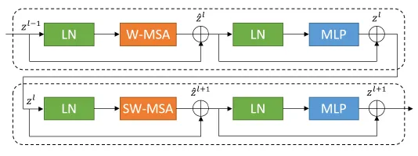
Figure 1: Swin Transformer Block (Cao et al., 2021)

Residual Connections
Residual connections are utilized and incorporated into the convolutional blocks of both the encoder and the decoder paths of the U-Net structure. (Träﬀ, 2023). These connections, typically implemented as identity mappings that add the input of a block to its output, play a vital role in the following:
- Alleviating Vanishing Gradients: They provide shorter paths for gradients to propagate during backpropagation, hence making it easier to train immensely deep networks (Träﬀ, 2023)
- Improving Feature Propagation: Providing shorter paths for gradients to propagate during backpropagation, making it easier to train very deep networks (Träﬀ, 2023).

Attention Mechanisms (Attention Gates)
The architecture incorporates attention mechanisms, specifically Attention Gates (AGs), within the skip connections. (Träﬀ, 2023)
- Placement: Attention Gates are typically placed where features from the encoder path are concatenated with the upsampled features in the decoder path
- Function: The AGs learn to automatically focus on the target structures of varying shapes and sizes, as well as suppress feature responses in irrelevant regions of the input image (Träﬀ, 2023). They take both the encoder feature map and the gating signal (from the lower decoder level) as inputs to compute attention coefficients. These coefficients then modulate the encoder features before they are fused with the decoder features.
- Benefits: This mechanism helps in bridging the semantic gap between the encoder and decoder features, ensuring that only the most relevant contextual information is propagated, thereby improving segmentation accuracy, especially for small complex structures (Al Qurri & Almekkawy, 2023; Angona & Mondal, 2025; Umarani et al., n.d.; Zhang et al., 2024)

The confluence of these elements - the multi-scale feature extraction capabilities of the U-Net, the global contextual modeling attributes of the Swin Transformer, the enhancement of deep network training facilitated by residual connections, and the refinement of features through attention mechanisms culminates in a robust architecture specifically designed for sophisticated medical image segmentation tasks. The particular ResAtt Swin-UNet configuration is delineated in the reference (Träﬀ, 2023) (comprising 4 U-Net levels, a Swin Transformer incorporated within the bottleneck featuring 1 stage, 6 attention heads, a patch size of 2 × 2, a window size of 7 × 7, an embedding dimension of 96, and the inclusion of attention gates within skip connections) will be utilized as the foundational architecture for this thesis. The efficacy of such a complex model is anticipated to exhibit a pronounced sensitivity to the selection of optimizer, which must adeptly traverse its intricate parameter landscape while maintaining a balance in learning across its varied convolutional and attention-driven components.

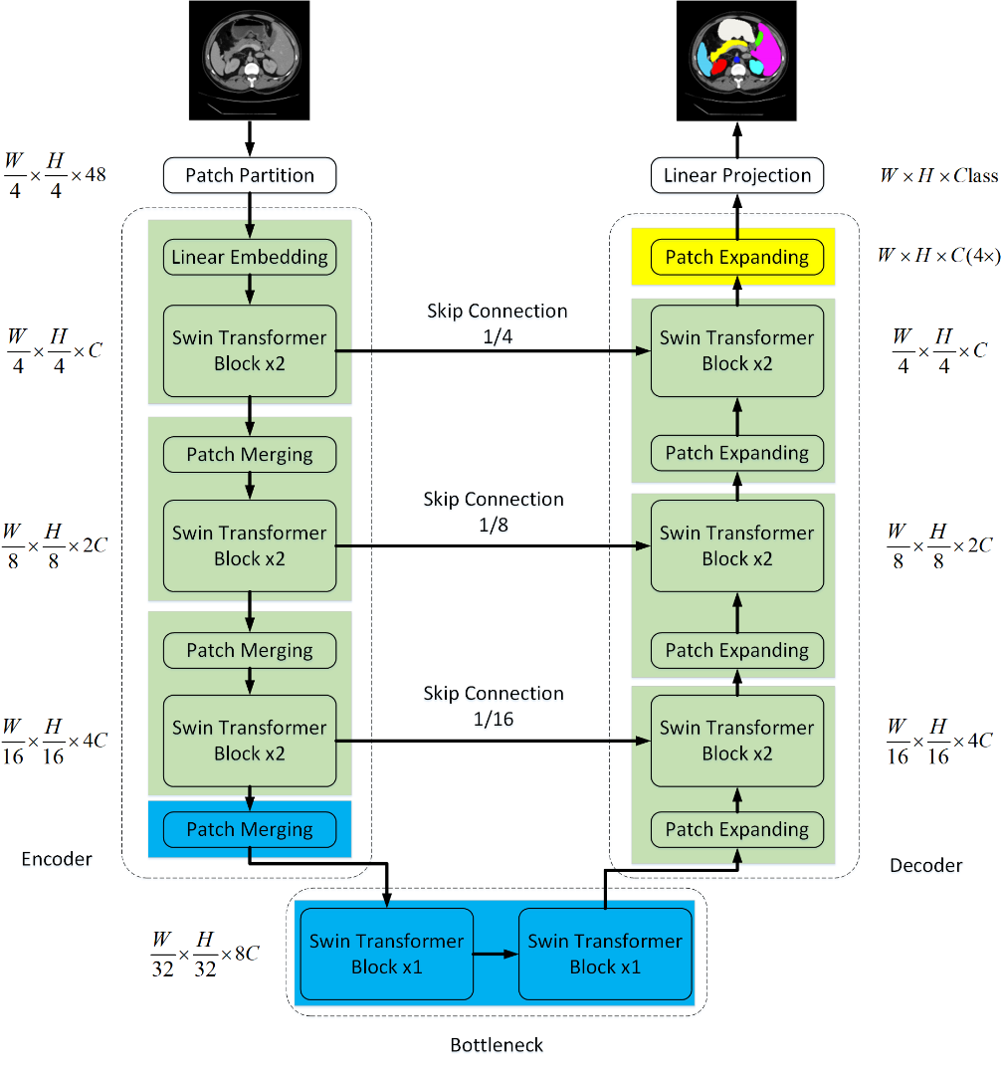
Figure 2: Swin-UNet architecture (Cao et al., 2021)

Adam Optimizer and Its Variants
The selection of an optimization algorithm is crucial in the training of deep neural networks, exerting a substantial influence on the convergence rate, stability, and the quality of the resultant model. The Adam (Adaptive Moment Estimation) optimizer (Kingma & Ba, 2017a) Has emerged as a de facto standard in numerous deep learning applications owing to its efficacy and its capacity for adaptive learning rates. Nevertheless, various adaptations have been proposed to mitigate specific limitations inherent in the original Adam or to provide advantages. This section meticulously examines Adam and the variants relevant to this thesis: AdamW, Adagrad, Adamax, Adafactor, and RMSProp.

Adam (Adaptive Moment Estimation)
Introduced by Kingma and Ba, the Adam optimizer combines the advantages of the two other popular optimization techniques: Adagrad (Adaptive Gradient Algorithm), which adapts learning rates for each parameter, and RMSProp (Root Mean Square Propagation). Which also uses adaptive learning rates based on a moving average of squared gradients (Offorjindu et al., 2025; Träﬀ, 2023). Adam computes individual adaptive learning rates for different parameters from estimates of first-order (mean) and second-order (uncentered variance) moments of the gradients. (Kingma & Ba, 2017a)
- Mathematical Formulation: Given g_{t} as the gradient at timestep t, θ_{t} being the parameters, α being the learning rate, β₁, β₂ being exponential decay rates for the moment estimates, and $ε$ be a small constant for numerical stability.
  - Update biased first moment estimate: $m_{t}=β_{1}m_{t-1}+\left(1-β_{1}\right)g_{t}$
  - Update biased second moment estimate: $v_{t}=β_{2}v_{t-1}+\left(1-β_{2}\right)g_{t}^{2}$
  - Compute bias-corrected first moment estimate: ${\overset{^}{m}}_{t}=\frac{m_{t}}{\left(1 -{ β}_{1}^{t}\right)}$
  - Compute biased-corrected second moment estimate: $\overset{^}{V_{t}}=\frac{v_{t}}{\left(1-β_{2}^{t}\right)}$
  - Update parameters: $θ_{t+1}=θ_{t}-α·\frac{{\overset{^}{m}}_{t}}{\left(1-β_{2}^{t}\right)}$
- Hyperparameter Considerations (Kingma & Ba, 2017a):
  - Learning rate (α): Typically, 0.001
  - β₁: Typically, 0.9
  - β₂: Typically, 0.999
  - Epsilon $(ε)$: Typically, 10⁻⁸

- Advantage: It’s computationally efficient, with little memory requirements, well-suited for problems with large data/parameters, noisy gradients, and non-stationary objectives. Magnitudes of parameter updates are invariant to gradient rescaling (Kingma & Ba, 2017a)
- Disadvantage: Can occasionally converge to less than optimal solutions or manifest challenges with generalization relative to Stochastic Gradient Descent with momentum in specific tasks. The application of L2 regularization or weight decay in the conventional Adam algorithm may prove to be ineffectual (Song, 2023).

AdamW (Adam with Decoupled Weight Decay)
Proposed by Loshchilov and Hutter (Loshchilov & Hutter, 2019). The AdamW optimizer modifies the way L2 regularization, also known as weight decay, is applied in Adam. Instead of adding the L2 penalty to the gradient (which interacts with the adaptive learning rates), AdamW decouples weight decay from the gradient update and applies it directly to the weights after the Adam step. (Loshchilov & Hutter, 2017; Zhuang et al., n.d.)
- Mathematical Formulation (Conceptual):
  - Perform the Adam update step as above (without the L2 term in $g_{t}$)
  - Apply weight decay $θ_{t+1}=θ_{t+1}-αλθ_{t}$ (where $λ$ is the weight decay factor, and this decay is often scaled by the learning rate or a schedule multiplier. More accurately, the weight decay is applied as such: $θ_{t+1}←θ_{t}-η_{t}\left(\frac{α{\overset{^}{m}}_{t}}{\sqrt{v_{t}}+ε} + λθt\right)$ for Adam with L2, compared to $θ_{t+1}←θ_{t}-η_{t}\left(\frac{α{\overset{^}{m}}_{t}}{\sqrt{v_{t}}+ε}\right)$ followed by $θ_{t+1}←θ_{t+1}-nx_{t+1}$ For AdamW, which is simplified and has an actual implementation that scales decay by the current rate. The key lies in the decoupling.
- Key differences from Standard Adam: The primary difference is the handling of weight decay, leading to potentially better generalization (Loshchilov & Hutter, 2017)
- Theoretical Advantages: Improves generalization by applying weight decay more effectively than standard Adam with L2 regularization. It decouples the choice of weight decay from the learning rate adaptation (Zhuang et al., n.d.)
- Potential Disadvantages: This approach remains an adaptive methodology and may exhibit some common generalization challenges associated with Adam under specific circumstances, although it is typically regarded as an enhancement (Zhuang et al., n.d.).
- Hyperparameter Considerations: In addition to Adam’s hyperparameters, a weight decay rate such as 0.01 needs to be set (Zhuang et al., n.d.)

Adagrad (Adaptive Gradient Algorithm)
Developed by Duchi, Hazan, and Singer (Duchi et al., n.d.), Adagrad adapts the learning for each parameter by dividing the global learning rate by the square root of the sum of all historical squared gradients for that parameter.
- Mathematical Formulation: Let $G_{t,ii}=\sum_{τ=1}^{t}{ }g_{τ,i}^{2}$ Be the sum of squared gradients for the parameter. $i$ up to timestamp $t$. Update parameters: $θ_{t+1, i} = θ_{t, i} - \frac{α}{\sqrt{G_{t, ii}}+ε}g_{t, i}$ (Duchi et al., n.d.)
- Key Differences from Standard Adam: Uses the cumulative sum of squared gradients, not an exponential moving average. Does not use momentum (first moment estimate) (Ioffe & Szegedy, 2015)
- Theoretical Advantages: Well-suited for sparse gradients, as infrequent parameters receive larger updates. Eliminates the need to manually tune the learning rate as much (Duchi et al., n.d.).
- Potential Disadvantages: The learning rate monotonically decreases and can become too small, which could stop the learning prematurely, especially in deep networks with many iterations. Memory-intensive as it stores all past squared gradients (Duchi et al., n.d.)
- Hyperparameter Considerations:
  - Learning Rate ($α$): Typically, 0.01
  - Epsilon $(ε)$: Small constant such as ${10}^{-8}$

Adamax (Adam Variant based on Infinity Norm)
Also introduced by Kingma and Ba in the original Adam paper (Kingma & Ba, 2017b). Adamax is a variant of Adam that uses the $l_{∞}$ norm (infinity norm) for the exponentially weighted average of past gradients, making it potentially more stable and robust than Adam, especially with noisy gradients
- Mathematical Formulation:
  - $m_{t}=β_{1}m_{t-1}+\left(1-β_{1}\right)g_{t}$
  - $u_{t}=max\left(β_{2} · u_{t-1}, \left|g_{t}\right|\right)$ (element-wise maximum, $u_{t }$ is the $l_{∞}$ norm-based second moment)
  - ${\overset{^}{m}}_{t} = \frac{m_{t}}{\left(1 - {β^{t}}_{1}\right)}$
  - $θ_{t+1}=θ_{t}-\left(α/{u_{t}}\right){\overset{^}{m}}_{t}$
- Key Differences from Standard Adam: Uses $l_{∞}$ norm for $v_{t}$ (denoted as $v_{t}$ here) instead of $l_{2}$ norm (squared $g$gradients).
- Theoretical Advantages: More stable update rule compared to Adam, especially when gradients are sparse or noisy. Less sensitivity to learning rate hyperparameter choices
- Hyperparameter Considerations:
  - Learning Rate ($α$): Typically, 0.002 (often the same as Adam’s default).
  - $β_{1}$: Typically, 0.9
  - $β_{2}$: Typically, 0.999
  - Epsilon $(ε)$: Typically, $1 × {10}^{-8}$.

Adafactor (Adaptive Learning Rates with Sublinear Memory Cost)
This variant of Adam was proposed by Shazeer and Stern, Adafactor (Shazeer & Stern, 2018) is designed to be memory-efficient, especially for large models, by maintaining factored estimates of the second-moment accumulators and optionally dropping momentum (Vyas et al., 2024).
- Mathematical Formulation (Conceptual):
  - It does not store the full second-moment matrix $V_{t}$; instead, for matrix parameters, it stores the moving averages of row and column sums of squared gradients $\left(R_{t}, C_{t}\right)$ and approximates $V_{t}≈ \frac{R_{t}{C^{T}}_{t}}{sum\left(R_{t}\right)}$ (Shazeer & Stern, 2018)
  - Often drops the first moment (momentum) estimate ($m_{t}$) or uses a very small $β_{1}$
  - Uses relative step size (scales LR parameter norm) and update clipping (Shazeer & Stern, 2018)
  - Employs an increasing $β_{2}$ schedule, such as $β_{2t} = 1 - t^{-c}$ (Shazeer & Stern, 2018).
- Key differences from Standard Adam: Memory efficiency through factored second moments and optional momentum removal, as well as the usage of relative step sizes and update clipping (Shazeer & Stern, 2018)
- Theoretical Advantages: Substantially reduces memory overhead, hence allowing training of larger models (Shazeer & Stern, 2018)
- Potential Disadvantages: Performance might be slightly worse than Adam's if momentum is crucial. The learning rate schedule and scaling are different from Adam, which requires a careful setup (Vyas et al., 2024)
- Hyperparameter Considerations:
Learning Rate ($lr$): Optional, often set to $None$ or a small value such as 0.01 if $relative step=True$ and $scale parameter=True$
  - $Beta decay$ or $Decay\text{ r}ate$: Controls $β_{2}$ schedule (such as -0.8 for $β_{2t} = 1 - t^{-0.8}$ (Shazeer & Stern, 2018).
  - Epsilon $(ε)$: Tuple for stability $\left({10}^{-30}, {10}^{-3}\right)$ (Shazeer & Stern, 2018)
  - $clipping\text{_threshold}$ (d): Typically 1.0 (Shazeer & Stern, 2018).
  - $\text{Weight Decay}$: 0.0

RMSProp (Root Mean Square propagation)
Proposed by Geoff Hinton in his lecture notes (Hinton, n.d.), RMSProp scales learning rates by dividing by a moving average of squared gradients. It is a precursor to Adam. (Huang et al., n.d.).
- Mathematical formulation:
  - Update biased squared gradient estimate: $E{\left[g^{2}\right]}_{t} =γE{\left[g^{2}\right]}_{t-1} + (1 - γ){g_{t}}^{2}$ (where $γ$ is the decay rate, often denoted $ρ$or $β_{2}$)
  - Update parameters: $θ_{t+1} = θ_{t} - \frac{α}{\sqrt{E{\left[g^{2}\right]}_{t} + ε}}g_{t}$
- Key differences from standard Adam: Does not include momentum (first momentum estimate) or bias correction for the second moment estimate.
- Theoretical Advantages: Addresses Adagrad’s rapidly diminishing learning rates by using an exponential moving average instead of a cumulative sum of squared gradients (L. Jiang, 2020). Suitable for non-stationary objectives (A Complete Guide to the RMSProp Optimizer, n.d.; Efimov, 2023)
- Potential Disadvantages: Performance can be sensitive to hyperparameter choices (RMSProp Optimizer in Deep Learning - GeeksforGeeks, n.d.)
- Hyperparameter Considerations:
  - Learning Rate ($α$): Typically, 0.001
  - Decay Rate ($γ$ or $ρ$): Typically, 0.9
  - Epsilon $(ε)$: Typically ${10}^{-8}$ or ${10}^{-6}$
  - $Momentum$: Optional, typically 0.0 for standard RMSProp

Comparative Analyses in Deep Learning
While empirical comparative investigations of the various Adam variants with complex hybrid Transformer-CNN models for 2D medical image segmentation are limited, several overarching observations can be articulated. The Adam optimizer and its derivatives (specifically AdamW and Adamax) are frequently preferred due to their robust nature and commendable default performance metrics. (Morrison & Ma, 2025). Adagrad is known for its usefulness with sparse data; however, its declining learning rate is a limitation. (Dogo et al., 2022). RMSProp is regarded as a reliable adaptive optimization technique and is often utilized as a foundational benchmark. The principal advantage of Adafactor lies in its memory efficiency, particularly when applied to huge models. The case presented in (“What Is RMSProp?,” n.d.) offers a direct comparative analysis utilizing a U-Net architecture for the BraTS 2020 dataset, revealing that Adamax achieved the highest recall. In contrast, Adam and AdamW demonstrated consistently strong overall performance. This thesis will expand upon these findings by scrutinizing these optimizers within the context of the more sophisticated Residual Attention Swin-UNet architecture. The "no free lunch" theorem suggests that the optimal choice of optimizer is contingent upon the specific problem at hand; consequently, empirical assessment, as outlined in this thesis, is of paramount importance. As such, choosing an optimizer significantly influences segmentation accuracy, training stability, and convergence speed, especially in complex architectures like the Residual Attention Swin-UNet, where convolutional and attention mechanisms create a complex optimization landscape.

The BraTS 2020 Dataset and Evaluation
The BraTS 2020 dataset serves as a benchmark for evaluating algorithms in brain tumor image analysis. The dataset is multi-institutional, containing contributions as MRI scans from different institutions, medical and academic. This ensured a degree of diversity in the data sources. (Crimi & Bakas, 2021; Träﬀ, 2023).
The dataset overview is as follows:
- Number of Cases: The BraTS 2020 training dataset comprises 369 patient cases. This includes 293 High-Grade Glioma (HGG) cases and 76 Low-Grade Glioma (LGG) cases. The validation set contains 125 cases, and the testing set consists of 166 cases. Ground truth labels were withheld by the organizers for blind evaluation.
- MRI Modalities: Each patient case includes four structural MRI sequences:
  - Native T1-weighted (T1)
  - Post-contrast T1-weighted (T1ce or T1Gd)
  - T2-weighted (T2)
  - T2 Fluid Attenuated Inversion Recovery (FLAIR) (Crimi & Bakas, 2021; Träﬀ, 2023)
- Image Characteristics: All provided MRI scans are co-registered to the same anatomical template, interpolated to a uniform isotropic resolution of ${1mm}^{3}$, and have undergone skull-stripping to remove non-brain tissue. The typical image dimensions are $240 × 240$pixels.

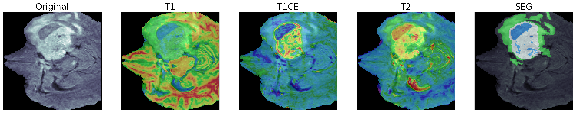
Figure 3: Swin Transformer Block (Cao et al., 2021)

The dataset also has ground truth segmentations that follow a specific annotation protocol. These segmentations for the training data are manually annotated by one to four experienced human raters, with final approval from expert neuroradiologists. These annotations delineate distinct tumor sub-regions:
- Label 1: Necrotic and Non-Enhancing Tumor core (NCR/NET)
- Label 2: Peritumoral Edema (ED)
- Label 4: GD-enhancing Tumor (ET)
- Label 0: This represents everything else (healthy tissue, background)
For evaluation purposes in the BraTS challenge, these labels are typically combined into three nested regions:
- Whole Tumor (WT): Encompasses all tumorous tissue, i.e., NCR/NET, ED, and ET (Labels 1, 2, and 4).
- Tumor Core (TC): Includes the NCR/NET and ET (Labels 1 and 4).
- Enhancing Tumor (ET): Consists only of the enhancing tumor region (Label 4).

The performance of the segmentation task and segmentation algorithms on the BraTS dataset is assessed using a standardized set of metrics:
- F1-Score (Dice Similarity Coefficient - DSC): This is the most common metric that measures the volumetric overlap between the predicted segmentation and the ground truth. It is calculated as $2 · \frac{\left|P ∩ G\right|}{\left(\left|P\right| + \left|G\right|\right)}$, where P is the prediction and G is the ground truth. Hence, return values with a range from 0 (meaning no overlap) to 1 (meaning a perfect overlap) (Crimi & Bakas, 2021; Müller et al., 2022; Sayed et al., 2024; Träﬀ, 2023)
- Jaccard Index (also known as Intersection over Union - IoU): This is another overlap-based metric, calculated as $\frac{\left|P ∩ G\right|}{\left|P ∪ G\right|}$ (Sayed et al., 2024; Träﬀ, 2023)
- Sensitivity (Recall): Measures the proportion of the actual negative pixels that are correctly identified, calculated as True Negatives divided by the sum of False Negatives and True Negatives $\frac{TN}{TN + FP}$ (Crimi & Bakas, 2021; Sayed et al., 2024; Träﬀ, 2023)
- Precision: Measures the proportion of predicted positive pixels that are positive, calculated as True Positives divided by the sum of True Positives and False Positives $\frac{TP}{TP + FP}$
The BraTS dataset's multimodal features, 3D volumetric data, and extensive annotations of clinically relevant sub-regions make it a challenging but comprehensive evaluation benchmark. The metrics employed for assessment are meticulously crafted to gauge both volumetric overlap and the precision of boundaries. A thorough comprehension of these dimensions is imperative, as the efficacy of an optimizer may fluctuate across various metrics and among distinct tumor sub-regions, which frequently display considerable class imbalance (for instance, the extent of enhancing tumors (ET) is generally substantially less than that of whole tumors (WT)). The selection of the loss function during the training phase of the model should ideally be congruent with these evaluation metrics to maximize the desired characteristics of performance.

Research Methodology
This section aims to describe the steps taken for studying the model performance with the Adam optimizer variants for brain tumor segmentation using the BraTS 2020 dataset. The model went through training through essential stages such as data preprocessing, augmentation pipelines, model implementation details, optimizer configurations, training protocols, and its evaluation via suitable metrics.

Dataset and Preprocessing
As previously stated in Section 2.4, the dataset comprises multimodal, multi-parametric MRI scans, including T1-weighted (T1), and post-contrast T1-weighted (T1ce). T2-weighted (T2) and T2 Fluid Attenuated Inversion Recovery (FLAIR) sequences for each patient. (Wang et al., 2023). The BraTS 2020 training set consists of 369 cases, 298 being HGG and 76 being LGG. Their corresponding manual annotations for enhancing tumor (ET), tumor core (TC), and whole tumor (WT) regions, will form the basis for training and validation.
The data is then randomized and split into training validation sets to ensure a comprehensive assessment of model's performance and dependable hyperparameter optimization (although having extensive hyperparameter tuning for each optimizer exceeds the primary focus), whereby a 5-fold cross-validation approach will be employed utilizing the official BraTS 2020 training dataset. (Crimi & Bakas, 2021; Talukder et al., 2025; ZongRen et al., 2023). For every fold, 80% of the dataset (approximately 295 subjects) will be allocated for the training of the model, while the remaining 20% (approximately 74 subjects) will function as the validation set for that specific fold, hence, facilitating the monitoring of training progression as well as the application of early stopping techniques. Performance metrics will be articulated as the mean and standard deviation across the five validation folds. This methodology ensures that the entire training data is utilized for both training and validation purposes throughout the comprehensive cross-validation process, resulting in more generalizable performance estimates. Consistent intensity normalization is crucial for training a stable deep learning model, especially with multimodal data originating from different scanners and institutions.
Patch Extraction or Cropping Strategy is performed afterwards. Given the large size of the MRI areas ($228 × 228$pixels) and typical GPU memory limitations, training will be performed using a patch-based approach. During training, 2D patches of a fixed size, specifically $128 × 128$ pixels, will be randomly extracted from the full volumes (Träﬀ, 2023; Wang et al., 2023). To ensure that the network learns from relevant regions, patch sampling will be biased towards containing tumorous tissue; for instance, if at least a certain percentage of its pixels belong to any of the tumor classes, or its center falls within the tumorous region, that patch will be accepted. This patch size is selected to provide sufficient context for the segmentation task while being manageable for the current GPU hardware with a small batch size. For inference on the validation folds, a sliding window approach with overlapping patches of the same size $128 × 128,$ will be used. Predictions in the overlapping regions will be averaged to produce a smooth, full-volume segmentation (Träﬀ, 2023). The choice of preprocessing steps, particularly normalization and patch extraction, directly influences the data distribution presented to the optimizers. Maintaining consistency in these steps across all experimental runs is paramount for a fair comparison of the optimizer variants.

Data Augmentation
Data augmentation is a critical technique in medical image analysis used to artificially expand the training dataset. This process enhances the model's ability to generalize, reduces the risk of overfitting, and improves its robustness to the natural variability found in clinical data (Bonato et al., 2025; Crimi & Bakas, 2021; Nalepa et al., 2019; Träﬀ, 2023). For this thesis, a data augmentation pipeline was constructed and applied to each 2D patch during training.
The augmentation pipeline was designed to introduce both spatial and intensity-based variations. The pipeline was configured to apply the exact same random transformation synchronously across all four MRI modalities (FLAIR, T1, T1ce, and T2) for each slice. This ensures that the anatomical alignment and spatial correspondence between the different image channels are perfectly preserved after augmentation, which is essential for effective multi-modal learning.
- Spatial Deformations: With an 80% probability for each training sample, one of the following geometric transformations was randomly selected and applied:
  - Elastic Transformations: This technique simulates non-linear tissue deformations, such as stretching or compressing, by applying a smooth displacement field to the image pixels. This helps the model become invariant with the natural anatomical variability and shape of tumors across different patients.
  - Grid Distortions: This method applies random shifts to points on a grid and then smoothly interpolates the image to fit the distorted grid. It creates localized, non-uniform distortions that can mimic complex tissue shifts or imaging artifacts.
  - Optical Distortions: This transformation simulates lens-like distortions, creating barrel or pincushion effects. It alters the spatial relationship of pixels in a non-linear fashion, further diversifying the geometric representations of the input data.
- Intensity Augmentation: Pixel Intensity Augmentations were applied independently with an 80% probability through the following:
  - Random Brightness and Contrast: This technique randomly adjusts the brightness and contrast of the image. It helps the model become less sensitive to variations in MRI scanner calibration and acquisition protocols, which can affect image intensity profiles.
By applying this augmentation pipeline, the model becomes exposed to a much wider variety of data than is present in the original training set. The parameters for each augmentation were kept constant across all experiments to ensure that any observed differences in performance can be confidently attributed to the optimizer variants rather than variations in the data distribution.

Residual Attention Swin-UNet Model Implementation
The core deep learning model for this thesis is the Residual Attention Swin-UNet. The specific configuration will be based on the ResAtt Swin-UNet architecture. (Träﬀ, 2023), which combines a U-Net backbone with residual connections, attention mechanisms in the skip connections, and a Swin Transformer block in the bottleneck. The model follows a UNet encoder-decoder structure with 4 levels of encoding and decoding.
The encoder path is as follows:
- Each of the 4 encoder levels will consist of residual blocks. A typical residual block will include two sequences of: Convolution (kernel size 3 × 3, padding 1) → Group Normalization → LeakyReLU activation (Träﬀ, 2023). An identity skip connection will sum the input of the block to its output (after the convolutions and activations) to form the residual connection. (Träﬀ, 2023).
- Downsampling between encoder levels will be achieved using max pooling layers (e.g., 2 × 2)
- The number of feature channels will typically start at an initial value (e.g., 16 or 32) in the first encoder level and double with each subsequent level (e.g., 16 → 32 → 64 → 128 channels).
The output of the final encoder level will be fed into a Swin Transformer block. (Träﬀ, 2023). This stage is known as the Bottleneck of the model. The configuration is based on:
- Number of Swin Transformer Stages: 1 stage
- Patch Size: 2 × 2
- Window Size: 8 × 8 for standard Swin Transformer, which often uses isotropic windows
- Embedding Dimension: 96.
- Number of Attention Heads: 6.
- MLP Ratio: Typically 4.0 for Swin Transformers (Träﬀ, 2023), though not explicitly stated for the MLP within the Swin block. Standard Swin Transformer block structure (W-MSA/SW-MSA, MLP) will be assumed.
The output of the Swin Transformer block will then pass through a convolutional layer to adjust the number of channels (such as 256) before entering the decoder path. (Träﬀ, 2023).
The decoder paths of the Swin U-Net model are as follows:
- Each of the 4 decoder levels will mirror the encoder structure, using residual blocks (two sequences of Convolution → Group Normalization → LeakyReLU) (Träﬀ, 2023).
- Upsampling between decoder levels will be performed using 3D Transposed Convolution layers (e.g., kernel 2 × 2, stride 2) (Träﬀ, 2023).
- The number of feature channels will halve with each subsequent decoder level (e.g., 256 → 128 → 64 → 32 → 16 channels) (Träﬀ, 2023).
An attention mechanism (in skip connections):
- Type: Attention Gates (AGs) will be implemented in the skip connections (Träﬀ, 2023).
- Placement: Before concatenating the feature maps from an encoder level with the upsampled feature maps from the corresponding lower decoder level, the encoder features will pass through an AG. The AG will also take the upsampled decoder features as a gating signal.
- Function: The AG will learn to assign higher weights to salient regions in the encoder feature maps that are relevant to the segmentation task at that particular scale, effectively filtering out irrelevant information before concatenation (Träﬀ, 2023).
Finally, an output layer is structured as follows:
- A terminal 1 × 1 two-dimensional convolutional layer followed by a sigmoid activation function (if approaching each tumor category as an independent binary segmentation task, which is consistent with the methodology by which Dice loss is frequently calculated per category) or a Softmax activation function (if conceptualizing it as a multi-class challenge with mutually exclusive labels assigned to each voxel, inclusive of background) will yield the segmentation probability maps for the designated classes (ET, TC, WT, or NCR, ED, ET and subsequently amalgamated) (Träﬀ, 2023). The resultant output will correspond to the dimensions of the input patch, predicting three channels that represent the tumor sub-regions.
This detailed architecture, particularly leveraging the specifics from (Träﬀ, 2023), provides a robust and state-of-the-art baseline for investigating optimizer performance. The precise number of channels per U-Net level will be as such: Encoder: 4 (input) → 16 → 32 → 64 → 128. Bottleneck (Swin + Conv): 128 → 256. Decoder: 256 → 128 → 64 → 32 → 16 → 3 (output classes). The implementation will be carefully documented to ensure reproducibility.

Adam Optimizer Variants: Setup and Hyperparameters
To facilitate a just and methodical comparison, every variant of the Adam optimizer that has been selected will be configured utilizing the widely acknowledged default parameters or settings that are suggested in their original scholarly articles, with a uniform initial learning rate and learning rate schedule implemented throughout all experimental trials, unless the inherent design of a particular optimizer necessitates a divergent methodology (for instance, the relative step size of Adafactor).
The optimizers to be investigated are as follows:
- Adam:
  - Learning Rate ($α$): $1 × {10}^{-4}$ (consistent initial learning rate for comparison, though $1 × {10}^{-3}$ It is a common default.
  - $β_{1}$: 0.9
  - $β_{2}$: 0.999
  - $Epsilon (ε)$: $1 × {10}^{-8}$
  - Weight Decay: Not intrinsically part of standard Adam; L2 regularization would be added to the loss if desired, but for this comparison, we focus on optimizer-native weight decay like in AdamW.
- AdamW (Adam with Decoupled Weight Decay):
  - Learning Rate ($α$): $1 × {10}^{-4}$
  - $β_{1}$: 0.9
  - $β_{2}$: 0.999
  - $Epsilon (ε)$: $1 × {10}^{-8}$
  - Weight Decay ($λ$): 0.01 (This is a common starting point that may require slight tuning if performance is poor, but will be kept fixed for the main comparison).
- Adagrad (Adaptive Gradient Algorithm):
  - Learning Rate ($α$): 0.01 (Adagrad often benefits from a larger initial learning rate as it decays aggressively). If $1 × {10}^{-4}$ is used for consistency and performs poorly, it will be noted.
  - Initial Accumulator Value: 0.1
  - $Epsilon (ε)$: $1 × {10}^{-7}$
- Adamax (Adam based on Infinity Norm):
  - Learning Rate ($α$): $1 × {10}^{-4}$ (though $2 × {10}^{-3}$ happens to be the default for Adamax, consistency is prioritized for this experiment.
  - $β_{1}$: 0.9
  - $β_{2}$: 0.999
  - $Epsilon (ε)$: $1 × {10}^{-8}$
- Adafactor (Adaptive Learning Rates with Sublinear Memory Cost):
  - Learning Rate ($α$): $None$ or 0.01 (if $\text{relative step = True}$, as $scale\text{ parameter} \text{=} \text{True}$ recommended in (Optimization, n.d.)). The learning rate is controlled by internal schedules and scaling.
  - $\text{Decay Rate}$: -0.8 (for $β_{2t} = 1 - t^{-0.8}$).
  - $Epsilon (ε)$ : ($1 × {10}^{-30}$, $1 × {10}^{-3}$)
  - $Clipping Threshold$: 1.0
  - $Relative Step$: $True$
  - $Scale Parameter$: $True$
  - $Weight Decay$: 0.0
  - $Momentum (β)$: Not used, hence effectively set to 0 as per original design for memory saving
- RMSProp (Root Mean Square Propagation):
  - Learning Rate ($α$): $1 × {10}^{-4}$
  - Decay Rate ($γ$): 0.9
  - $Epsilon (ε): 1 × {10}^{-8}$
  - $Momentum$: 0.0

Justification for Hyperparameter Choices:
The initial learning rate of $1 × {10}^{-4}$ is chosen as a common starting point for many Adam-based optimizers in medical imaging tasks, for other parameters such as $β_{1}, β_{2}, ε$standard default values from the original papers or widely adopted library defaults will be used to ensure a baseline comparison that reflects the common practice. For AdamW, a weight decay of 0.01 is a typical value. Adafactor’s parameters are set based on its original paper’s recommendations for achieving good performance with memory efficiency. (Shazeer & Stern, 2018). Adagrad and RMSProp will utilize their widely acknowledged default settings. The principal aim is to examine the intrinsic behaviors of these optimization algorithms under a relatively equitable and standardized configuration, rather than engaging in comprehensive hyperparameter tuning for each, which could obscure the comparison. Any notable divergences from conventional defaults or performance complications arising from these selections will be recorded and analyzed. All optimization algorithms will adhere to the identical learning rate schedule described in the subsequent section.

Training Configuration
To ensure a fair and rigorous comparison of the optimizer variants, the following training configurations will be strictly adhered to for all experiments:
- Loss Function: A combined loss function, DiceCELoss, will be employed. This loss function is the sum of the Dice Loss and the multi-class Cross-Entropy Loss and has demonstrated robust performance in medical image segmentation tasks, including the BraTS challenges (Crimi & Bakas, 2021; Lyu & Tian, 2025; Träﬀ, 2023; Yousef et al., 2023). The Dice Loss component directly optimizes the Dice Similarity Coefficient for each of the three target tumor regions (Enhancing Tumor - ET, Tumor Core - TC, and Whole Tumor - WT). The Cross-Entropy Loss component provides smooth gradients and helps with overall classification accuracy at the voxel level. The formulation is as follows: $L_{DiceCE} = (ω_{Dice} · L_{Dice }) + (ω_{CE} · L_{CE})$, hence adhering to (Träﬀ, 2023), equal weights will be used, i.e., $ω_{Dice} = 1.0$ and $ω_{CE} = 1.0$. Hence, the multi-class Dice loss will be calculated as the average Dice loss across the ET, TC, and WT regions.
- Learning Rate Schedule: A polynomial decay learning rate schedule will be used for all optimizers (Crimi & Bakas, 2021; Jerónimo et al., 2024). This schedule gradually reduces the learning rate from an initial value to a final value over a specified number of decay steps (total training iterations/epochs). The formula is as such, $lr_{current} = (lr_{initial} - lr_{end}) · {(1 - \frac{current\text{_iteration}}{total\text{_iterations}})}^{0.9} + lr_{end}$. The initial learning rate ($lr_{initial}$) will be $1× {10}^{-4}$ for all optimizers (as specified in Section 3.4). The $lr_{end}$ will be set to a smaller value, such as $1× {10}^{-6}$ with the power value set to 0.9, which is a common setting for polynomial decay, similar to that used in nnU-Net (Träﬀ, 2023). This consistent schedule ensures that all optimizers experience the same learning rate dynamics throughout training
- Batch Size: Given the considerable memory demands associated with three-dimensional operations and the intricate nature of the Residual Attention Swin-UNet architecture, a training batch size of 2 will be implemented, utilizing 128 × 128 pixel patches (Angona & Mondal, 2025). In instances of severe memory limitations, gradient accumulation may be utilized to emulate a larger effective batch size, as previously demonstrated by (Crimi & Bakas, 2021)(Crimi & Bakas, 2021) (where a simulated batch size of 8 was achieved). For this strategy, a direct batch size of 2 is presupposed.
- Number of Epochs: The models will be trained for a total of 200 epochs. An epoch is defined as one complete pass through all the training patches generated from the training subjects within a given fold of the cross-validation. This number is chosen to allow sufficient time for convergence for most optimizers, based on typical training durations for segmentation models on BraTS (Weninger et al., n.d.).
- Early Stopping Criteria: To mitigate the risk of overfitting and minimize redundant computations, an early stopping strategy will be employed. The training process will be terminated if the mean Dice Similarity Coefficient on the validation dataset for the current fold fails to show improvement over a specified number of consecutive epochs (known as patience). A patience threshold of 30 epochs will be established (Crimi & Bakas, 2021; Mulqueeney et al., 2024; Rainio & Klén, 2025). The model parameters associated with the epoch that demonstrate the highest validation Dice score will be preserved for the final assessment.
By keeping these training configuration parameters, loss function, learning rate schedule, batch size, total epochs, and early stopping criteria identical across all optimizer experiments, any observed differences in performance can be more confidently attributed to the optimizers themselves rather than to variations in the training setup. This methodological consistency is crucial for the validity of comparative analysis.

Evaluation Protocol
The efficacy of the Residual Attention Swin-UNet architecture, when subjected to training with each variant of the chosen Adam optimizer, will undergo a comprehensive evaluation utilizing a blend of quantitative metrics, qualitative analyses, and rigorous statistical significance assessments.
Quantitative Metrics: The principal evaluation criterion will hinge upon the accuracy of segmentation pertaining to three clinically pertinent tumor sub-regions: Whole Tumor (WT), Tumor Core (TC), and Enhancing Tumor (ET). The subsequent standard metrics, which are extensively recognized in the BraTS challenge and the corpus of medical image segmentation research, will be calculated for each sub-region (Crimi & Bakas, 2021; Müller et al., 2022; Sayed et al., 2024; Träﬀ, 2023):
- Dice Similarity Coefficient (DSC): Measures the volumetric overlap between the predicted segmentation and the ground truth. $DSC=\frac{2 · \left|P ∩ G\right|}{\left|P\right| + \left|G\right|}$
- Jaccard Index (Intersection over Union - IoU): Another measure of overlap. $IoU=\frac{|P ∩ G|}{|P ∪ G|}$
- Sensitivity (Recall): Measures the true positive rate, i.e., the proportion of actual tumor pixels correctly identified. $Sensitivity = \frac{TP}{TP+FN}$​
- F1-score: Measure of a model's accuracy, specifically for binary classification problems. It's the harmonic mean of precision and recall, balancing the trade-off between these two metrics. $F1score = 2 × \frac{Precision·Recal}{Precision+Recall}$
- Precision: Measures the positive predictive value, i.e., the proportion of predicted tumor pixels actually represent a tumor. $Precision = \frac{TP}{TP+FP}$
For each optimizer, these metrics will be calculated for every subject in the validation set of each fold of the 5-fold cross-validation. The final reported quantitative results will be the mean and standard deviation of these metrics across all subjects from all test folds, providing an estimate of average performance and its variability.
Qualitative Assessment: Beyond numerical scores, a qualitative analysis of the segmentation results will be performed. This will involve:
- Visual inspection of the segmentation outputs overlaid on the corresponding MRI slices for a selection of representative cases. These cases will include examples where models perform well, achieve average results, and encounter challenges (e.g., patients with very small enhancing tumors, diffuse tumor boundaries, or unusual tumor morphology).
- Comparison of segmentation quality across different optimizers for these selected cases, noting any systematic error patterns such as consistent over- or under-segmentation of specific regions, issues with boundary smoothness, or difficulties in distinguishing between sub-regions.

Experimental Results and Analysis
This chapter presents the observed findings from the comparative analysis of the Adam optimizer variants highlighted in this thesis. The results are detailed through a compact analysis of quantitative metrics and training dynamics, followed by a qualitative visual assessment of the segmentation outputs.

Quantitative Performance and Training Dynamics
The primary evaluation of the optimizers was based on their final performance on the validation set after 200 epochs. The key metrics, summarized in Table 1, reveal a clear performance hierarchy.
Table 1: Comparative Segmentation Performance of Adam Optimizer Variants
Optimizer | Train Loss | Valid Loss | F1-Score | IoU Score | Precision | Recall
Adam | 0.2103 | 0.2274 | 0.7931 | 0.6919 | 0.8319 | 0.7985
AdamW | 0.2071 | 0.2354 | 0.7820 | 0.6792 | 0.8509 | 0.7634
Adagrad | 0.2654 | 0.2729 | 0.7331 | 0.6266 | 0.7964 | 0.7437
Adamax | 0.2475 | 0.2505 | 0.762 | 0.6515 | 0.7724 | 0.7993
Adafactor | 0.2607 | 0.2689 | 0.7429 | 0.6357 | 0.778 | 0.7643
RMSProp | 0.2693 | 0.2729 | 0.7145 | 0.6121 | 0.8531 | 0.6949

The standard Adam optimizer achieved the highest F-score (0.7931) and IoU score (0.6919), establishing it as the most effective optimizer for overall segmentation accuracy by providing the best balance between precision and recall.

The training and validation loss curves, presented in Figure 4 and 5, illustrate the optimization process for each optimizer over 200 epochs

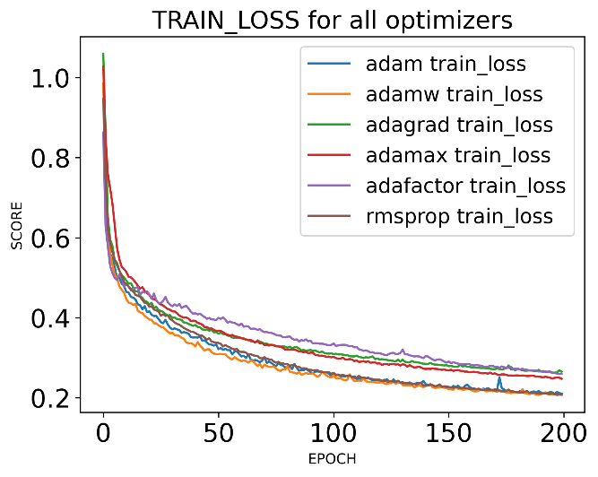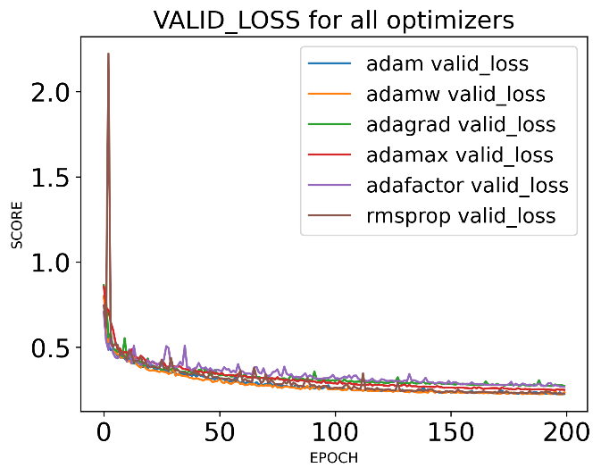
Figure 4, 5: Training and Validation losses across all optimizer variants

A clear differentiation is observed among the optimizers as seen in the curves above. Adam and AdamW consistently achieved the lowest loss values, indicating superior optimization and generalization. While AdamW reached the lowest training loss, Adam secured the lowest final validation loss, suggesting a slight advantage in generalization. The other four optimizers formed a distinct cluster with higher and more volatile loss values, indicating they were less effective at minimizing the loss function for this model.

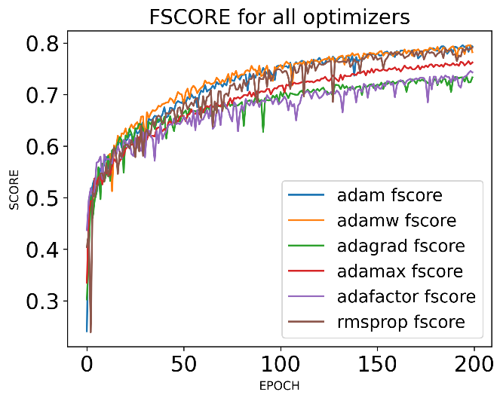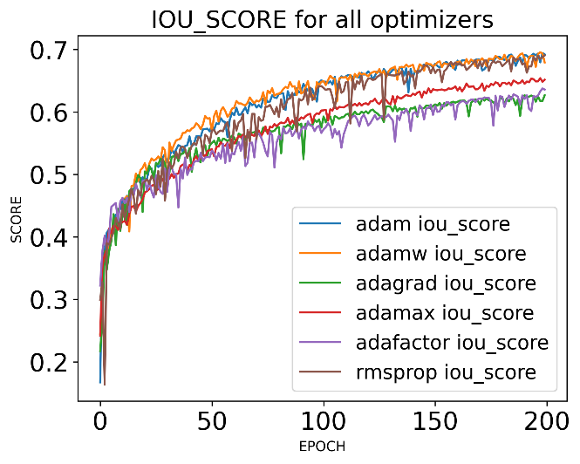
Figure 6, 7: F1-scores and IoU scores across all optimizer variants
Theses plots show the progression of the F1-score (left) and IoU score (right) on the validation set over 200 epochs. They also mirror the trends shown in convergence. The F1-score and IoU plots show Adam maintaining a consistent gap over AdamW after the initial learning phase. This confirms that while both are top performers, Adam's stability leads to a better result. The curves for Adagrad, Adafactor, and RMSProp are visibly noisier and plateau at a much lower performance level, suggesting less stable and effective learning.

Qualitative Evaluation
To complement the quantitative metrics, a qualitative analysis of the segmentation results was performed.
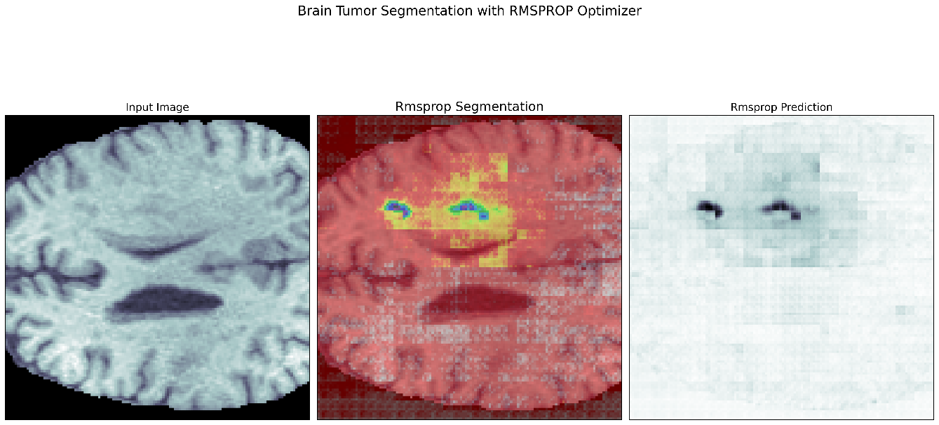
The following images provide a visual comparison of the segmentation outputs for each optimizer on representative axial MRI slices.
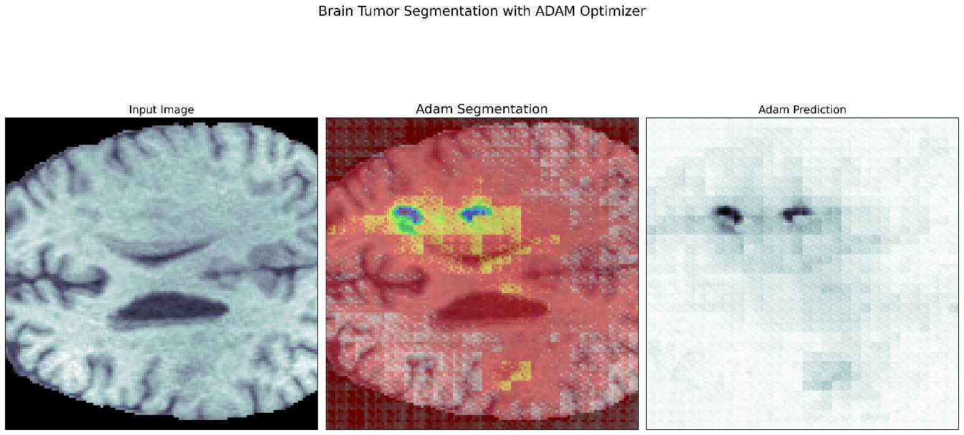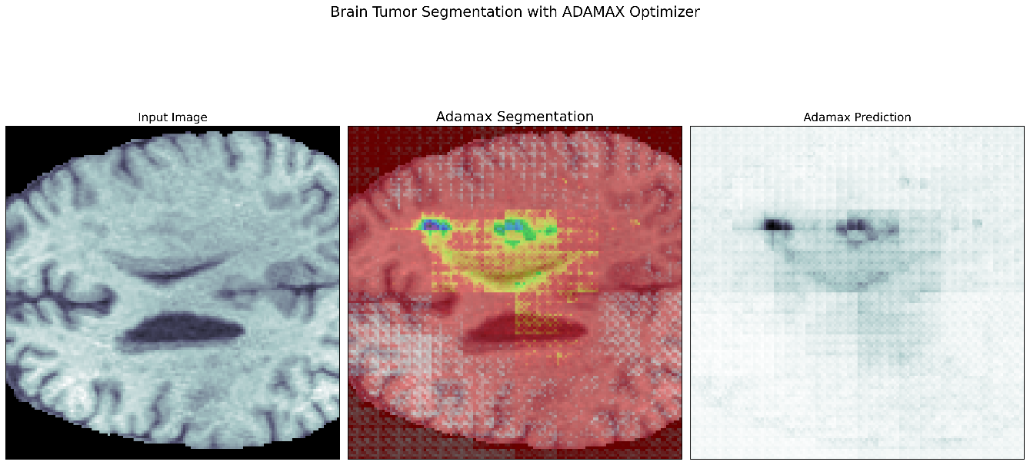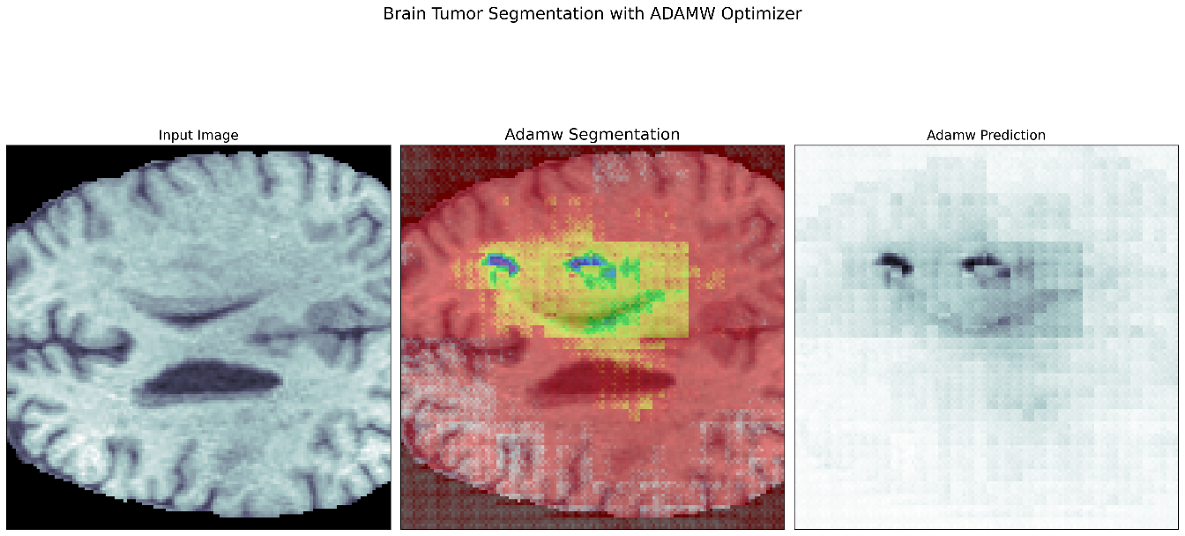
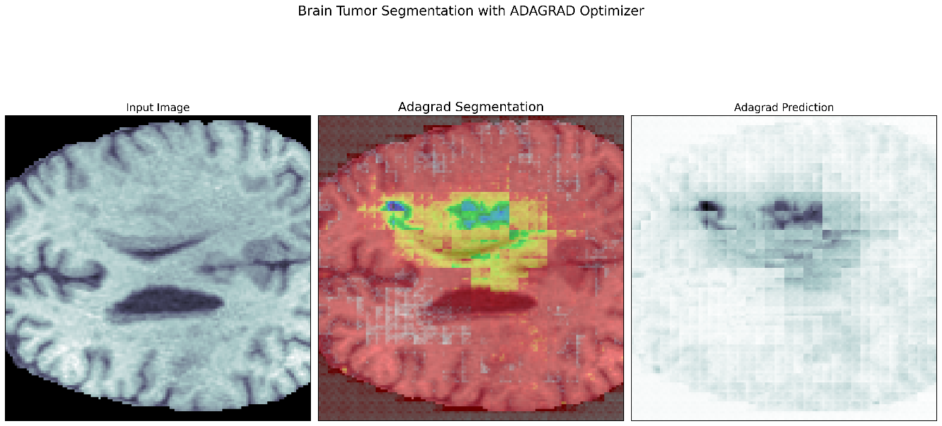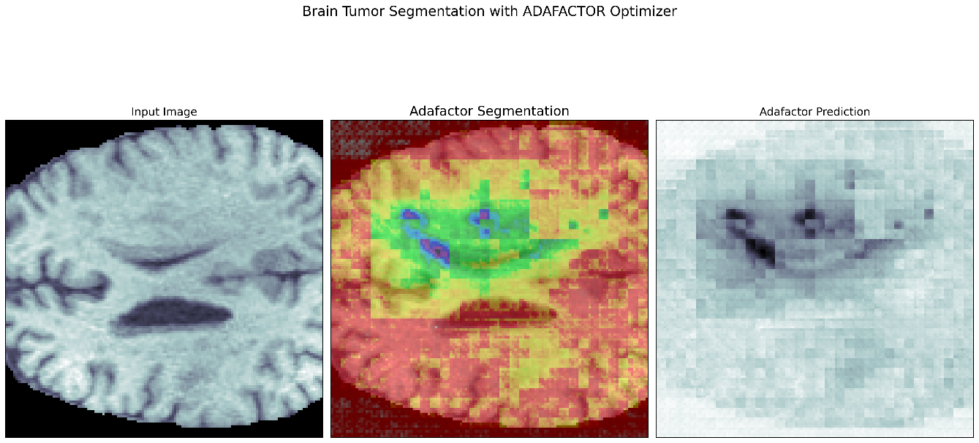
Figure 8 - 13: Segmentation results across all Adam optimizer variants
This visual comparison shows the predicted segmentation masks generated by all six optimizers. The segmentation overlay uses a color gradient to differentiate between various tumor sub-regions, while a prediction heatmap delineates the model's raw output probabilities. The visual findings give a concrete comprehension of each optimizer's characteristics and strongly affirm the quantitative results:
- Top Performers (Adam and AdamW): The segmentations produced by Adam and AdamW are visually superior. The boundaries of the tumor regions are well-defined, compact, and closely align with the anatomical structures. Their prediction heatmaps are focused and show a high confidence, hence proving their strong F1-score and IoU metrics.
- High-Recall Optimizer (Adamax): The Adamax segmentation successfully identifies the general tumor area, but the result appears blocky and less precise. This visual outcome aligns perfectly with its quantitative profile, and as such, a high recall score at the expense of lower precision.
- Lower Performers (Adagrad, Adafactor, RMSProp): The segmentations from these optimizers are visibly noisy and inaccurate. They exhibit significant over-segmentation, particularly of the peritumoral edema, which bleeds into healthy tissue. Their prediction heatmaps are diffuse and blurry, consistent with their low F1-scores and IoU scores.
In conclusion, the qualitative evaluation demonstrates that Adam and AdamW can produce clinically reasonable and reliable segmentations. In contrast, the other variants yield results with significant artifacts that are unsuitable for clinical use.

Precision-Recall Tradeoff Analysis
The experimental results reveal a distinct tradeoff between precision and recall among the different optimizer variants, a critical consideration in medical image segmentation. The evolution of these metrics during training, shown in Figure 11, 12, provides a dynamic view of this trade-off.

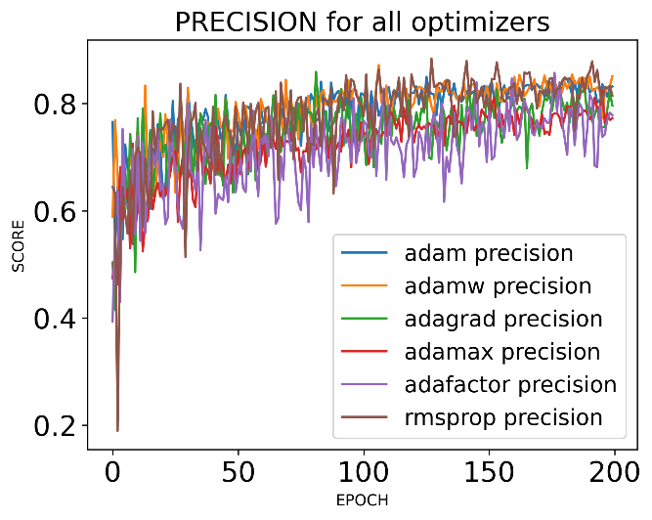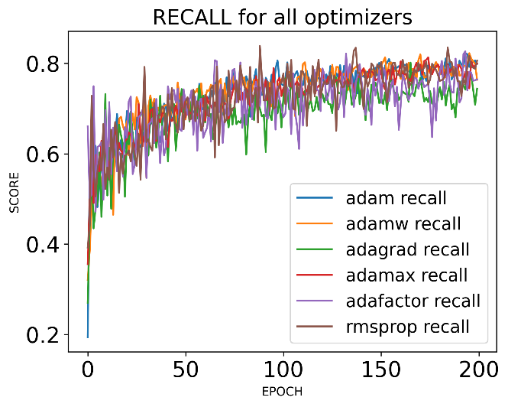
Figure 14, 15: Precision and Recall across all optimizer variants

The plots show the progression of Precision (left) and Recall (right) on the validation set over 200 epochs. However, with a combination of readings from Table 1 and Figure 14 and 15, this research can draw the following context:
- High-Precision Optimizers: AdamW and RMSProp came out as the optimizers with the highest precision, 0.8531 and 0.8509 respectively. Optimizers that aid models in obtaining such metrics are suitable for surgical planning because they minimize the risk of resecting healthy tissue. Recall was however compromised, which means these optimizers were more likely to miss parts of the tumor.
- High-Recall Optimizer: Adamax showed the highest recall with 0.7993, making it the most effective at delineating entire tumorous regions. This is good because it ensures that no cancerous tissue is overlooked during screening. However, another tradeoff takes place when balanced by precision and this is confirmed by the blocky, less-defined segmentations as shown in Figure 9.
- Balanced Performance: The Adam optimizer achieved the better equilibrium between precision and recall, obtaining scores of 0.8319 and 0.7985 respectively, hence its F1-score being the highest, making it the ideal optimizers comprehensive segmentations while maintaining a low rate of false alarms.
This analysis emphasizes that the selection of an optimizer can be customized to cater to specific clinical requirements. Should the paramount objective be the avoidance of healthy tissue removal at all costs, a high-precision optimizer such as RMSProp or AdamW may be favored. Conversely, if the priority lies in ensuring that no segment of the tumor is overlooked, a high-recall optimizer like Adamax could be contemplated. Nevertheless, for a robust and versatile clinical instrument, the balanced methodology of the standard Adam optimizer has proven to be the most efficacious in this investigation.

Discussion
This chapter provides an in-depth interpretation of the experimental findings that should connect the observed performance context of the Adam optimizer variants to their theoretical mechanisms and the specific challenges posed by the Residual Attention Swin-UNet architecture itself.

Interpretation of Findings
From this research, it was made clear that Adam and AdamW, due to ability to combine momentum known as first-moment estimates, with adaptive learning rates also known as second-moment estimates. This mechanism is well-suited for the complex loss landscape of the model, the Residual Attention Swin-UNet. The momentum component was probably of help to the optimizers in navigating through flat regions and saddle points, while the adaptive learning rates effectively managed the different gradients arising from the diverse layers, including the convolutional, self-attention, and attention gates.
This slight advantage from Adam in validation losses and F1-score over AdamW is also an interesting discovery. Although AdamW’s decoupled weight decay is theoretically better for generalization (Loshchilov & Hutter, 2019), its good precision and poor recall suggest it was slightly too conservative in this specific setup. It regularized the model effectively at the cost of capturing the full extent of the tumor boundaries as well as the more balanced Adam optimizer did.
The promise presented by the theoretical design of Adamax aligned with its performance, particularly in achieving the highest recall. Due to its utilization of the infinity norm, it is less sensitive to large, noisy gradients, hence allowing it to maintain larger and more stable updates and aggressively explore the parameter space to identify all potential tumor regions (Kingma & Ba, 2017b). This confirms the hypothesis that it would act as the “aggressive detector.”
On the contrary, the results showed poor performance of Adagrad and RMSProp, and this can be said due to their algorithmic limitations in this context. Firstly, Adagrad’s learning rate decays too aggressively while the sum of squared gradients grows monotonically, causing the model’s learning to stall prematurely before the model could learn the intricate features of the tumor sub-regions (Duchi et al., n.d.). RMSProp lacks Adam’s momentum and bias correction, and because of this, it struggled to escape suboptimal local minima, hence resulting in the highest validation loss and lowest F1-score.

Comparison with Existing Work
The findings presented in this thesis provide valuable context when compared with existing literature. The key point of comparison, as seen the research done in (Träﬀ, 2023), evaluated a similar set of optimizers using the BraTS 2020 dataset while using a U-Net model, found Adamax to be the top performing optimizer, whereas the results from this thesis find Adam as the most effective for hybrid models such as the Residual Attention Swin-UNet architecture. This discrepancy, hence, suggests that the optimal choice in optimizers is highly dependent on model’s architecture. The complexities of the bottleneck, residual connections and attention gates, housed in the Swin Transformer likely create a much different optimization landscape that benefits optimizers with balanced adaptive moments such as Adam.

Conclusion
This thesis conducted a systematic comparative analysis of six Adam optimizer variants - AdamW, Adagrad, Adamax, Adafactor, and RMSProp - on a Residual Attention Swin-UNet model for the BraTS 2020 brain tumor segmentation task. The empirical results, supported by both quantitative metrics and qualitative visual assessment, demonstrated a clear performance hierarchy among the optimizers. Standard Adam emerged as the most effective choice, delivering the best overall F-score (0.7931) and achieving a robust balance between precision and recall. Its convergence was stable, and the resulting segmentations were visually the most accurate and reliable.
AdamW proved to be a strong alternative, particularly for applications where precision is paramount, such as surgical planning. It achieved high precision and the lowest training loss, though its overall F-score was slightly behind Adam due to a lower recall. Conversely, Adamax distinguished itself with the highest recall, making it a potential candidate for initial screening tasks where capturing the entire tumor extent is the primary goal, albeit with a higher risk of false positives. The remaining optimizers - Adagrad, Adafactor, and RMSProp - were significantly outperformed, yielding noisy, inaccurate segmentations and demonstrating less effective convergence, confirming that the choice of optimizer has a critical impact on the final model quality. Based on these findings, standard Adam is recommended for general-purpose segmentation with this architecture due to its balanced and superior performance. However, for specific clinical needs, AdamW (for high precision) or Adamax (for high recall) could be considered.
This research highlights that optimizer performance is highly dependent on the model architecture, as our findings differ from studies using simpler U-Nets. Future work should focus on several key areas to build upon these results. First, conducting an exhaustive, individualized hyperparameter search for each optimizer could reveal further performance nuances. Second, extending this comparative analysis to other advanced architectures and different medical imaging datasets would be crucial to test the generalizability of these findings. Finally, exploring ensemble methods that combine models trained with different top-performing optimizers, such as Adam and AdamW, could potentially yield even more robust and accurate segmentation models, further advancing the capabilities of automated tools in clinical settings.

Literature
- A Complete Guide to the RMSprop Optimizer. (n.d.). Built In. Retrieved June 20, 2025, from https://builtin.com/articles/rmsprop-optimizer
- Al Qurri, A., & Almekkawy, M. (2023). Improved UNet with Attention for Medical Image Segmentation. Sensors, 23(20), 8589. https://doi.org/10.3390/s23208589
- Angona, T. M., & Mondal, M. R. H. (2025). An attention based residual U-Net with swin transformer for brain MRI segmentation. Array, 25, 100376. https://doi.org/10.1016/j.array.2025.100376
- Bonato, B., Nanni, L., & Bertoldo, A. (2025). Advancing Precision: A Comprehensive Review of MRI Segmentation Datasets from BraTS Challenges (2012–2025). Sensors, 25(6), 1838. https://doi.org/10.3390/s25061838
- Cao, H., Wang, Y., Chen, J., Jiang, D., Zhang, X., Tian, Q., & Wang, M. (2021). Swin-Unet: Unet-like Pure Transformer for Medical Image Segmentation (No. arXiv:2105.05537). arXiv. https://doi.org/10.48550/arXiv.2105.05537
- Crimi, A., & Bakas, S. (Eds.). (2021). Brainlesion: Glioma, Multiple Sclerosis, Stroke and Traumatic Brain Injuries: 6th International Workshop, BrainLes 2020, Held in Conjunction with MICCAI 2020, Lima, Peru, October 4, 2020, Revised Selected Papers, Part II (Vol. 12659). Springer International Publishing. https://doi.org/10.1007/978-3-030-72087-2
- Dogo, E. M., Afolabi, O. J., & Twala, B. (2022). On the Relative Impact of Optimizers on Convolutional Neural Networks with Varying Depth and Width for Image Classification. Applied Sciences, 12(23), 11976. https://doi.org/10.3390/app122311976
- Duchi, J., Hazan, E., & Singer, Y. (n.d.). Adaptive Subgradient Methods for Online Learning and Stochastic Optimization.
- Efimov, V. (2023, December 30). Understanding Deep Learning Optimizers: Momentum, AdaGrad, RMSProp & Adam. Towards Data Science. https://towardsdatascience.com/understanding-deep-learning-optimizers-momentum-adagrad-rmsprop-adam-e311e377e9c2/
- Hinton, G. (n.d.). Neural Networks for Machine Learning.
- Huang, H., Wang, C., & Dong, B. (n.d.). Nostalgic Adam: Weighing more of the past gradients when designing the adaptive learning rate.
- Ioffe, S., & Szegedy, C. (2015). Batch Normalization: Accelerating Deep Network Training by Reducing Internal Covariate Shift (No. arXiv:1502.03167). arXiv. https://doi.org/10.48550/arXiv.1502.03167
- Jerónimo, A., Valenzuela, O., & Rojas, I. (2024). Statistical Analysis of nnU-Net Models for Lung Nodule Segmentation. Journal of Personalized Medicine, 14(10), 1016. https://doi.org/10.3390/jpm14101016
- Jiang, L. (2020, June 7). A Visual Explanation of Gradient Descent Methods (Momentum, AdaGrad, RMSProp, Adam). Towards Data Science. https://towardsdatascience.com/a-visual-explanation-of-gradient-descent-methods-momentum-adagrad-rmsprop-adam-f898b102325c/
- Jiang, P., Liu, W., Wang, F., & Wei, R. (2025). Hybrid U-Net Model with Visual Transformers for Enhanced Multi-Organ Medical Image Segmentation. Information, 16(2), 111. https://doi.org/10.3390/info16020111
- Kingma, D. P., & Ba, J. (2017a). Adam: A Method for Stochastic Optimization (No. arXiv:1412.6980). arXiv. https://doi.org/10.48550/arXiv.1412.6980
- Kingma, D. P., & Ba, J. (2017b). Adam: A Method for Stochastic Optimization (No. arXiv:1412.6980). arXiv. https://doi.org/10.48550/arXiv.1412.6980
- Lee, S., & Lee, M. (2024). MetaSwin: A unified meta vision transformer model for medical image segmentation. PeerJ Computer Science, 10, e1762. https://doi.org/10.7717/peerj-cs.1762
- Liu, Z., Lin, Y., Cao, Y., Hu, H., Wei, Y., Zhang, Z., Lin, S., & Guo, B. (2021). Swin Transformer: Hierarchical Vision Transformer using Shifted Windows (No. arXiv:2103.14030). arXiv. https://doi.org/10.48550/arXiv.2103.14030
- Llugsi, R., Yacoubi, S. E., Fontaine, A., & Lupera, P. (2021). Comparison between Adam, AdaMax and Adam W optimizers to implement a Weather Forecast based on Neural Networks for the Andean city of Quito. 2021 IEEE Fifth Ecuador Technical Chapters Meeting (ETCM), 1–6. https://doi.org/10.1109/ETCM53643.2021.9590681
- Loshchilov, I., & Hutter, F. (2017). Decoupled Weight Decay Regularization (Version 3). arXiv. https://doi.org/10.48550/ARXIV.1711.05101
- Loshchilov, I., & Hutter, F. (2019). Decoupled Weight Decay Regularization (No. arXiv:1711.05101). arXiv. https://doi.org/10.48550/arXiv.1711.05101
- Lyu, Y., & Tian, X. (2025). MWG-UNet++: Hybrid Transformer U-Net Model for Brain Tumor Segmentation in MRI Scans. Bioengineering, 12(2), 140. https://doi.org/10.3390/bioengineering12020140
- Morrison, N., & Ma, E. Y. (2025). Efficiency of machine learning optimizers and meta-optimization for nanophotonic inverse design tasks. APL Machine Learning, 3(1), 016101. https://doi.org/10.1063/5.0238444
- Mortazi, A., Cicek, V., Keles, E., & Bagci, U. (2023). Selecting the Best Optimizers for Deep Learning based Medical Image Segmentation (No. arXiv:2302.02289). arXiv. https://doi.org/10.48550/arXiv.2302.02289
- Müller, D., Soto-Rey, I., & Kramer, F. (2022). Towards a guideline for evaluation metrics in medical image segmentation. BMC Research Notes, 15(1), 210. https://doi.org/10.1186/s13104-022-06096-y
- Mulqueeney, J. M., Searle-Barnes, A., Brombacher, A., Sweeney, M., Goswami, A., & Ezard, T. H. G. (2024). How many specimens make a sufficient training set for automated 3D feature extraction? Evolutionary Biology. https://doi.org/10.1101/2024.01.10.575054
- Nalepa, J., Marcinkiewicz, M., & Kawulok, M. (2019). Data Augmentation for Brain-Tumor Segmentation: A Review. Frontiers in Computational Neuroscience, 13, 83. https://doi.org/10.3389/fncom.2019.00083
- Offorjindu, S., Marjanović, M., & Bezdan, T. (2025). Effects of Adam Optimizer Variants on Brain Tumor Segmentation Task. Proceedings of the International Scientific Conference - Sinteza 2025, 41–47. https://doi.org/10.15308/Sinteza-2025-41-47
- Optimization. (n.d.). Retrieved June 21, 2025, from https://huggingface.co/docs/transformers/v4.52.3/main_classes/optimizer_schedules
- Rainio, O., & Klén, R. (2025). Modified Dice Coefficients for Evaluation of Tumor Segmentation from PET Images: A Proof-of-Concept Study. Journal of Imaging Informatics in Medicine. https://doi.org/10.1007/s10278-025-01535-1
- RMSProp Optimizer in Deep Learning—GeeksforGeeks. (n.d.). Retrieved June 20, 2025, from https://www.geeksforgeeks.org/deep-learning/rmsprop-optimizer-in-deep-learning/
- Ronneberger, O., Fischer, P., & Brox, T. (2015). U-Net: Convolutional Networks for Biomedical Image Segmentation (Version 1). arXiv. https://doi.org/10.48550/ARXIV.1505.04597
- Sayed, M., Saba-Sadiya, S., Wichtlhuber, B., Dietz, J., Neitzel, M., Keller, L., Roig, G., & Bucher, A. (2024). Evaluating Medical Image Segmentation Models Using Augmentation. Tomography, 10(12), 2128–2143. https://doi.org/10.3390/tomography10120150
- Shazeer, N., & Stern, M. (2018). Adafactor: Adaptive Learning Rates with Sublinear Memory Cost (No. arXiv:1804.04235). arXiv. https://doi.org/10.48550/arXiv.1804.04235
- Song, C. (2023). The performance analysis of Adam and SGD in image classification and generation tasks. Applied and Computational Engineering, 5(1), 757–763. https://doi.org/10.54254/2755-2721/5/20230697
- Talukder, M. A., Layek, M. A., Hossain, M. A., Islam, M. A., Nur-e-Alam, M., & Kazi, M. (2025). ACU-Net: Attention-based convolutional U-Net model for segmenting brain tumors in fMRI images. DIGITAL HEALTH, 11, 20552076251320288. https://doi.org/10.1177/20552076251320288
- Träff, H. (2023). Comparative Analysis of Transformer and CNN Based Models for 2D Brain Tumor Segmentation (Dissertation). Retrieved from https://urn.kb.se/resolve?urn=urn:nbn:se:liu:diva-195095
- Umarani, C. M., Gollagi, D. S. G., Bamane, D. K. D., Gupta, P., More, S. J., & Ankali, D. S. B. (n.d.). Accurate Segmentation of Brain Tumor Image using U-Net Based Self- Attention Mechanism.
- Vyas, N., Morwani, D., & Kakade, S. (2024). AdaMeM: Memory Efficient Momentum for Adafactor.
- Wang, P., Yang, Q., He, Z., & Yuan, Y. (2023). Vision transformers in multi-modal brain tumor MRI segmentation: A review. Meta-Radiology, 1(1), 100004. https://doi.org/10.1016/j.metrad.2023.100004
- Weninger, L., Rippel, O., Koppers, S., & Merhof, D. (n.d.). Segmentation of Brain Tumors in 3D-MRI Data and Patient Survival Prediction: Methods for the BraTS 2018 Challenge.
- What is RMSProp? Principles & Advantages. (n.d.). Deepchecks. Retrieved June 20, 2025, from https://www.deepchecks.com/glossary/rmsprop/
- Yao, W., Bai, J., Liao, W., Chen, Y., Liu, M., & Xie, Y. (2024). From CNN to Transformer: A Review of Medical Image Segmentation Models. Journal of Imaging Informatics in Medicine, 37(4), 1529–1547. https://doi.org/10.1007/s10278-024-00981-7
- Yousef, R., Khan, S., Gupta, G., Siddiqui, T., Albahlal, B. M., Alajlan, S. A., & Haq, M. A. (2023). U-Net-Based Models towards Optimal MR Brain Image Segmentation. Diagnostics, 13(9), 1624. https://doi.org/10.3390/diagnostics13091624
- Zhang, L., Li, Y., Liang, Y., Xu, C., Liu, T., & Sun, J. (2024). Dilated multi-scale residual attention (DMRA) U-Net: Three-dimensional (3D) dilated multi-scale residual attention U-Net for brain tumor segmentation. Quantitative Imaging in Medicine and Surgery, 14(10), 7249–7264. https://doi.org/10.21037/qims-24-779
- Zhuang, Z., Liu, M., Cutkosky, A., & Orabona, F. (n.d.). Understanding AdamW through Proximal Methods and Scale-Freeness.
- ZongRen, L., Silamu, W., Yuzhen, W., & Zhe, W. (2023). DenseTrans: Multimodal Brain Tumor Segmentation Using Swin Transformer. IEEE Access, 11, 42895–42908. https://doi.org/10.1109/ACCESS.2023.3272055

